Studying Companion

Adam Harb, Mohammad Zaatari, Joe Hage
Department of Computer Science, American University of Beirut
CMPS 271: Software Engineering
Georges Hatem
March 5, 2023

Product Vision 3
Description 3
Project Personas 3
I. Regular Student / Student with learning difficulties 3
II. Collaborative Student 4
III. Test-Taker 4
Product Backlog 5
UML Diagrams (All diagrams are inside this lucid chart) 9
Use Case Diagram 9
Sequence Diagram 10
Activity Diagram 12

Product Vision

Description
Students that need an app which assists with studying (especially those with dyslexia, adhd & other learning difficulties). The studying companion is an educational software that aids students in studying. Unlike other websites such as Pomofocus.io, Our product offers a unique set of features that are designed to help students stay organized, manage their time effectively, and maximize their learning potential. With the Studying Companion, students can collaborate with peers, and track their progress over time, all within a single, user-friendly platform. Whether they're studying for an exam, completing coursework, or just looking to brush up on their skills, our product is the perfect companion for any student who wants
to take their learning to the next level.

What is the product to be developed?
- The Study Companion is an educational tool that assists students in their learning process.
Who are the target customers and users?
- Students that need an app which assists with studying (especially those with dyslexia, adhd & other learning difficulties)
Why should customers buy this product?
- Unlike other websites such as Pomofocus.io, Our product offers a unique set of features that are designed to help students stay organized, manage their time effectively, and maximize their learning potential. With the Studying Companion, students can collaborate with peers, and track their progress over time, all within a single, user-friendly platform. Whether they're studying for an exam, completing coursework, or just looking to brush up on their skills, our product is the perfect companion for any student who wants to take their learning to the next level.

Project Personas

Regular Student / Student with learning difficulties
Name: Ahmad
Age: 19
Education: College
Ahmad is a student that has ADHD. He struggles to manage his time effectively and often finds himself procrastinating. This has resulted in poor academic performance and increased stress levels. Ahmad's goal is to improve his study habits and maintain focus while studying. He needs an app that will guide him through studying and has everything he needs in one place.

Scenarios:
- Ahmad has an important exam coming up in two weeks, but he hasn't started studying yet. He's been putting it off because he feels overwhelmed and doesn't know where to start.
- Ahmad has a programming assignment due in two days, but he's having trouble focusing. He is feeling stressed and overwhelmed because he has a programming assignment due in two days, and he hasn't made much progress on it yet. He's been having trouble focusing because he keeps getting distracted by his phone and social media.

Collaborative Student
Name: John Doe
Age: 20
Education: College
John Doe, A student at AUB wants to work with his classmates on a project and distribute the work on one-another through an organized To-Do list as well as grant access to his teacher for supervising.
Scenarios:
- John wants to work with his team for their compiler course project. In order to sort tasks they need to clearly group their tasks. He’d like to enter google docs directly from the tasks in the case where multiple documents are needed for each part of the project. The team would also appreciate it if they could sort my tasks by importance. Sharing with Teachers might be beneficial in order for them to check that all Students are working on their assigned tasks and not slacking.
- John would like to share his project with my teammates or even share it with the Studying Companion community or check out other projects by students in order to take inspiration or check if they are on the right track.

Test-Taker
Name: Joe Al Hage
Age: 25
Education: College

Name: Jenny
Age: 18
Education: High School

Scenarios:
- Joe Al Hage is a job applicant who is preparing to take a pre employment assessment test. He uses the website to find study materials on logical reasoning and numerical aptitude. He takes several timed practice tests to improve his speed and accuracy and receives feedback on his answers. He also connects with other job applicants who are preparing for the same test and gets advice on how to perform well under pressure.
- Jenny is a high school student who is preparing to take the SAT. She creates an account on the website and searches for study materials on math and reading comprehension. She saves some of the materials to her account and takes a practice test to gauge her current level of understanding. Based on her results, she creates a study plan for the next few weeks that focuses on her areas of weakness.

Product Backlog

ID | User Stories | Engineering Activities | Estimate | Priority
1 | As a student, I want to able to track time | Implementing a timer | 2 days | Highest
2 | As a student, I want to be able to manage my tasks | Implementing a task management interface / to do list | 3 days | High
3 | As a collaborative student, I want to share a To-do list with my team. | Develop a feature which enables two types of sharing:  view-only or editing | 4 days | Medium
4 | As a Collaborative Student, I want to be able to sort the tasks by importance. | Add a feature for choosing how to prioritize tasks, either by fibonacci numbers, ordinary numbers, words etc… | 1 day | High
5 | As a Test Taker, I want to be able to customize my study plan based on my strengths and weaknesses. | Develop a personalized study plan feature | 2 days | Medium
6 | As a student, I would like to share this task list by link. | Add a sharing option to the todo list | 4 days | Medium
7 | As a Test Taker, I want to be able to search for my lists | Implement search functionality for to do lists | 1 day | Low
8 | As a Test Taker, I want to be able to take timed practice tests. | Develop a timed test feature (stopwatch) | 1 day | Low
10 | As a student, I would appreciate finding projects like mine to have a general idea. | Adding multiple filters in order to find a precise and similar project.As well as set | 3 days | Low
11 | Distinguish tasks easily via images | Implement an AI bot that reads the prompt for the task and retrieves an image related to that improvement | 2 days | Low
12 | Toggle on and off whatever features I need | Implement a settings page that changes the way the website interacts with the user | 1 week | High
13 | Meditate and wind down | Implement a page with timer and music to wind down | 3 days | Medium
14 | Watch educational videos while studying | Integrated video player | 4 days | Medium
15 | Highlight and edit documents | Implement a page where you can upload your own document or edit a document from a certain url | 3 days | High

UML Diagrams (All diagrams are inside this lucid chart)

Use Case Diagram 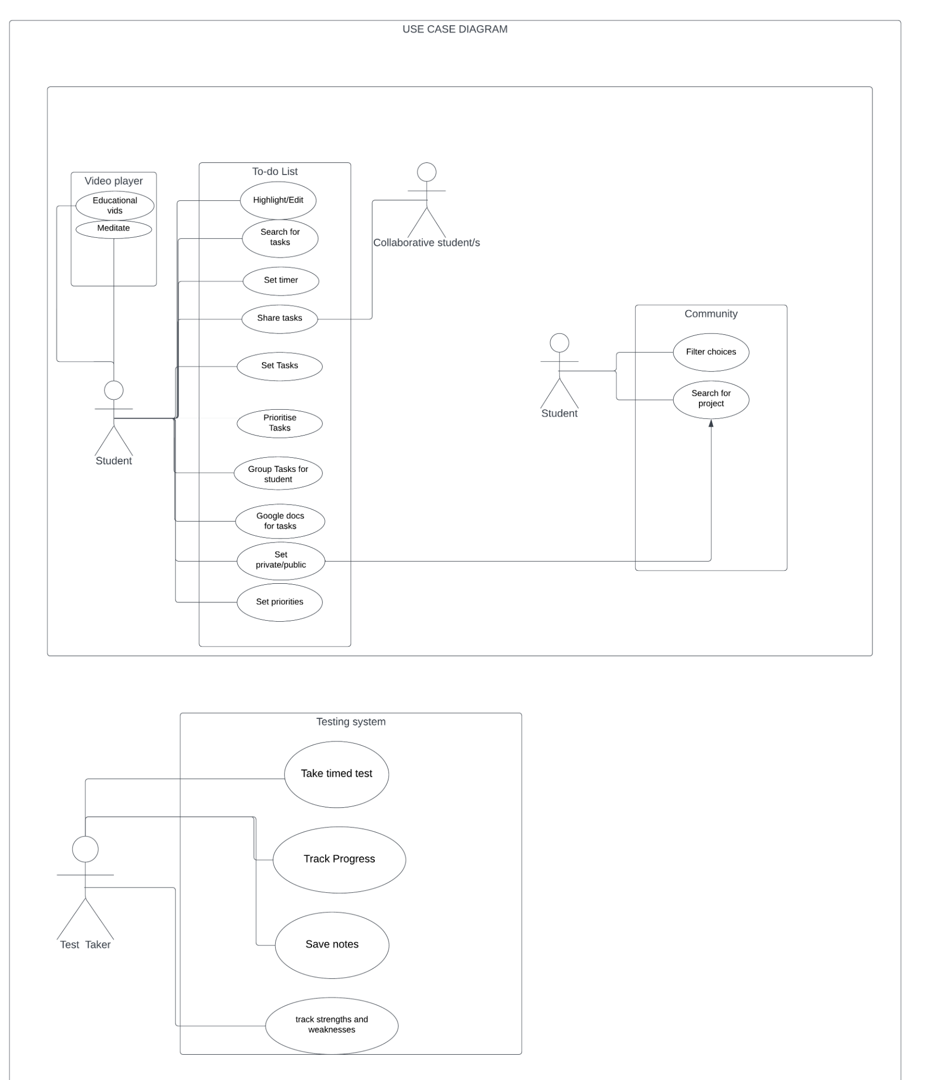

Sequence Diagram

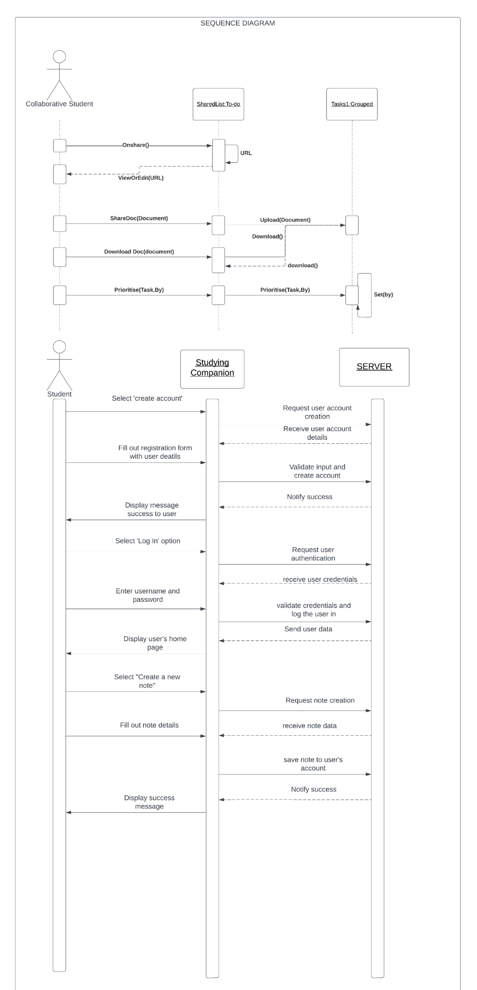

Activity Diagram
